* [Infrastructure Preview](https://googlecloud.qwiklabs.com/focuses/3289" \l "infrastructure-preview)
* [Overview](https://googlecloud.qwiklabs.com/focuses/3289#overview)
  + [**What you will do:**](https://googlecloud.qwiklabs.com/focuses/3289#what-you-will-do)
  + [**You will learn:**](https://googlecloud.qwiklabs.com/focuses/3289#you-will-learn)
* [Use Cloud Launcher to build a deployment](https://googlecloud.qwiklabs.com/focuses/3289#use-cloud-launcher-to-build-a-deployment)
  + [**Step 1: Go to Cloud Launcher**](https://googlecloud.qwiklabs.com/focuses/3289#step-1-go-to-cloud-launcher)
  + [**Step 2: Launch**](https://googlecloud.qwiklabs.com/focuses/3289#step-2-launch)
* [Examine the deployment](https://googlecloud.qwiklabs.com/focuses/3289#examine-the-deployment)
  + [**Step 1: View installed software**](https://googlecloud.qwiklabs.com/focuses/3289#step-1-view-installed-software)
  + [**Step 2: Locate login information**](https://googlecloud.qwiklabs.com/focuses/3289#step-2-locate-login-information)
  + [**Step 3: Go to the admin interface**](https://googlecloud.qwiklabs.com/focuses/3289#step-3-go-to-the-admin-interface)
  + [**Step 4: Explore the application**](https://googlecloud.qwiklabs.com/focuses/3289#step-4-explore-the-application)
* [Administer the service](https://googlecloud.qwiklabs.com/focuses/3289#administer-the-service)
  + [**Step 1: View the Deployment**](https://googlecloud.qwiklabs.com/focuses/3289#step-1-view-the-deployment)
  + [**Step 2: SSH to the Virtual Machine**](https://googlecloud.qwiklabs.com/focuses/3289#step-2-ssh-to-the-virtual-machine)
  + [**Step 3: Administratively shut down the services**](https://googlecloud.qwiklabs.com/focuses/3289#step-3-administratively-shut-down-the-services)
  + [**Step 4: Administratively restart the services**](https://googlecloud.qwiklabs.com/focuses/3289#step-4-administratively-restart-the-services)
* [Review](https://googlecloud.qwiklabs.com/focuses/3289#review)

# INFRASTRUCTURE PREVIEW

# Overview

In this lab you will build a sophisticated deployment in minutes using Cloud Launcher. This lab shows several of the GCP infrastructure services in action and illustrates the power of the platform. It introduces technologies that will be covered in detail later in the class.

## ****What you will do:****

* Use Cloud Launcher to build a Jenkins Continuous Integration environment.
* Verify that you can manage the service from the Jenkins UI.
* Administer the service from the Virtual Machine host through SSH.

## ****You will learn:****

* Deployment creation using Cloud Launcher
* Experience GCP automation of virtual machine and network setup

# Use Cloud Launcher to build a deployment

## ****Step 1: Go to Cloud Launcher****

Navigate to the Cloud Launcher service.

Console: **Products and Services > Cloud Launcher**

Locate the Jenkins deployment. It looks like this:

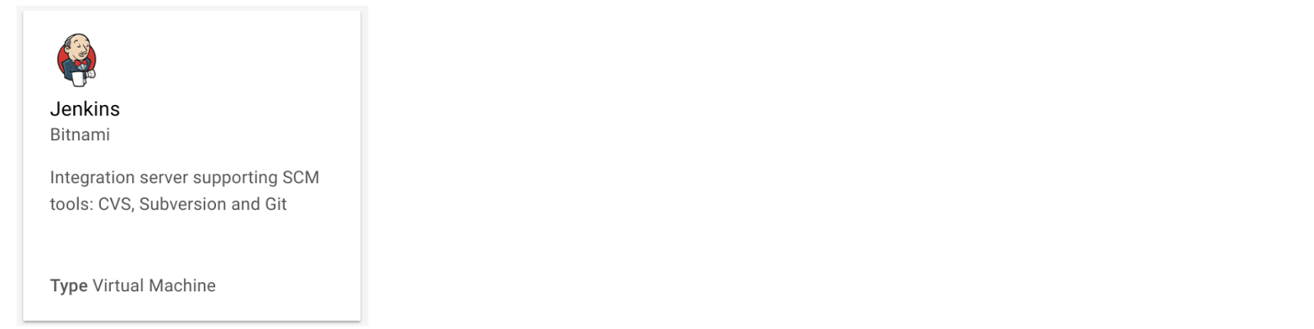

Click on the deployment. And read about the service provided by the software.

Jenkins is an open source continuous integration environment. You can define jobs in Jenkins that can perform tasks such as running a scheduled build of software and backing up data. Notice the software that is installed as part of Jenkins shown in the right side of the description.

The service you are using, Cloud Launcher, is part of Google Cloud Platform. The Jenkins template is developed and maintained by an ecosystem partner named Bitnami. Notice on the right side a field that says "**Last updated:**" How recently was this template updated?

The template system is part of another GCP service called Deployment Manager. Later in this class you will learn how templates such as this one can be built. That service is available to you. You can create templates like the one you are about to use.

In one class that we used to offer, students would setup a Jenkins environment similar to the one you are about to launch. It took about two days of labs to build the infrastructure that you will achieve in the next few minutes.

## ****Step 2: Launch****

Click on **[Launch on Compute Engine]**

Result:

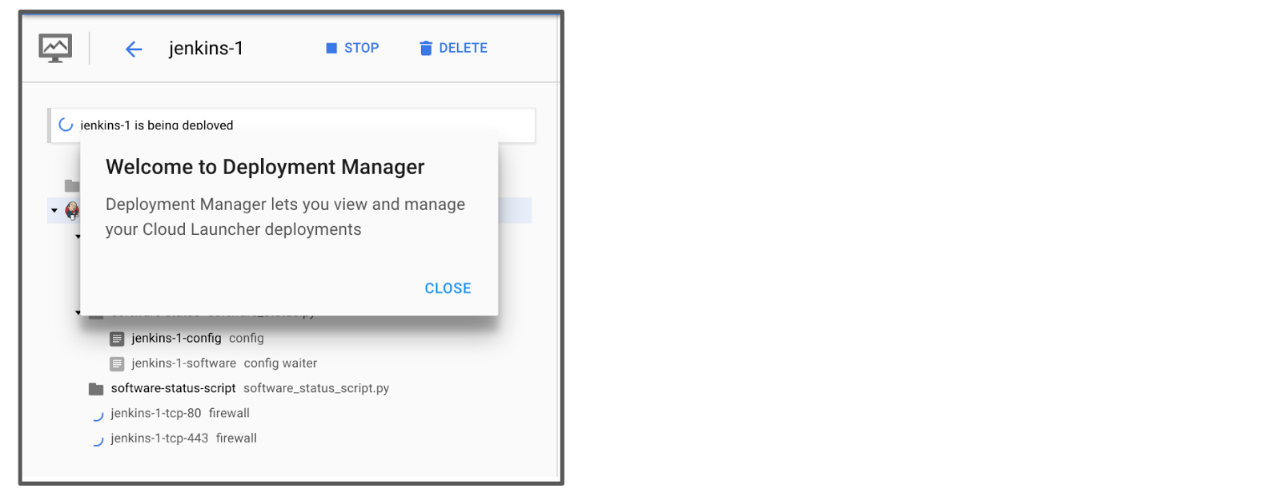

Cloud Launcher has loaded the template and switched you into the Deployment Manager service. You can click **[CLOSE]** on the dialog box. It will take a minute or two for Deployment Manager to setup the deployment. You can watch the status as tasks are being performed. Deployment Manager is acquiring a virtual machine instance and installing and configuring software for you.

Wait for the process to complete.

Result:



Deployment Manager is a GCP service that uses templates written in a combination of YAML, python, and Jinja2 to automate the allocation of GCP resources and perform setup tasks. Behind the scenes a virtual machine has been created. A startup script was used to install and configure software. And network Firewall Rules were created to allow traffic to the service.

# Examine the deployment

In this section you will investigate what was built in GCP.

## ****Step 1: View installed software****

Examine the information. Click on **[More]** to view additional software details. Look at all the software that was installed.

Result:

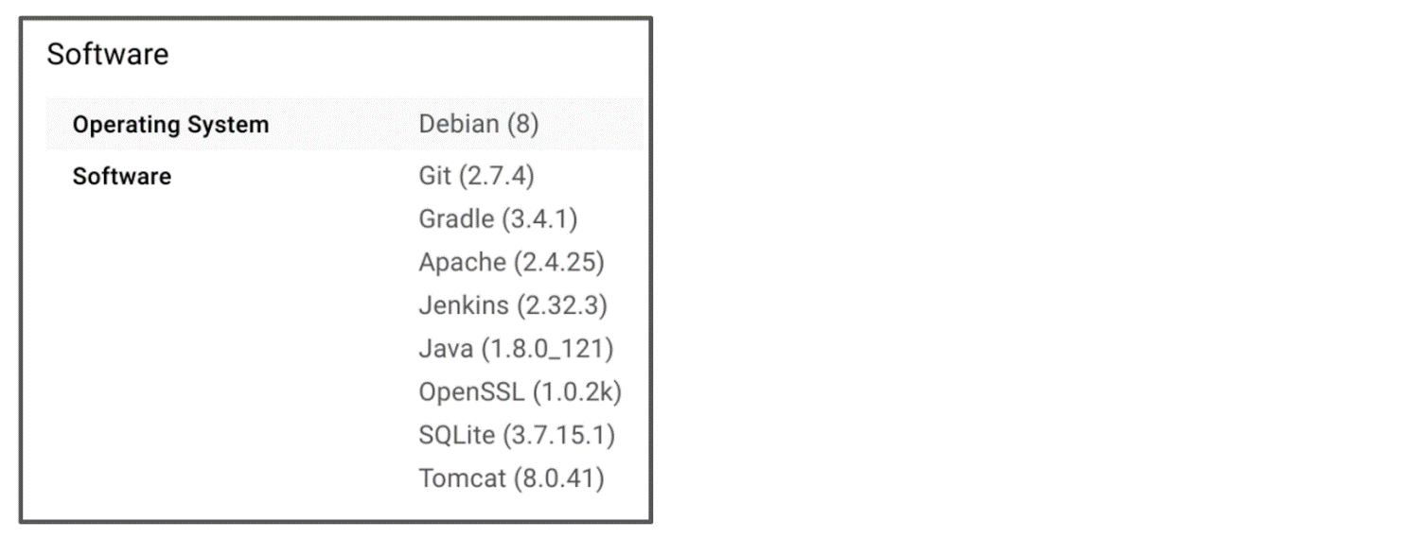

## ****Step 2: Locate login information****

Locate the Admin user name and the Admin password. Select and copy the password. You will use it to login in the next steps.

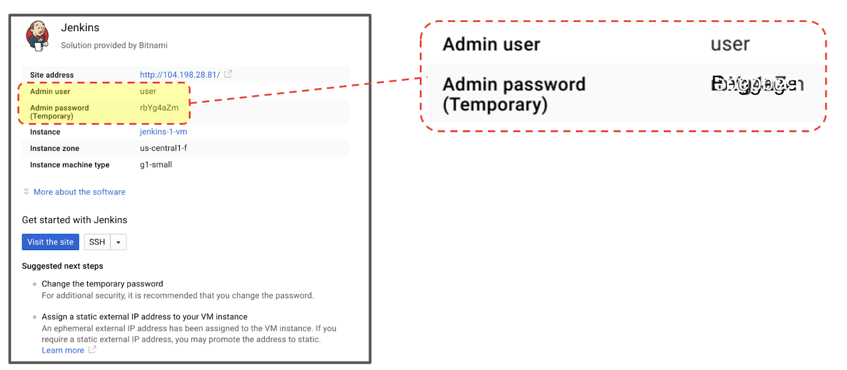

## ****Step 3: Go to the admin interface****

Click on the button to view the site in another browser tab.

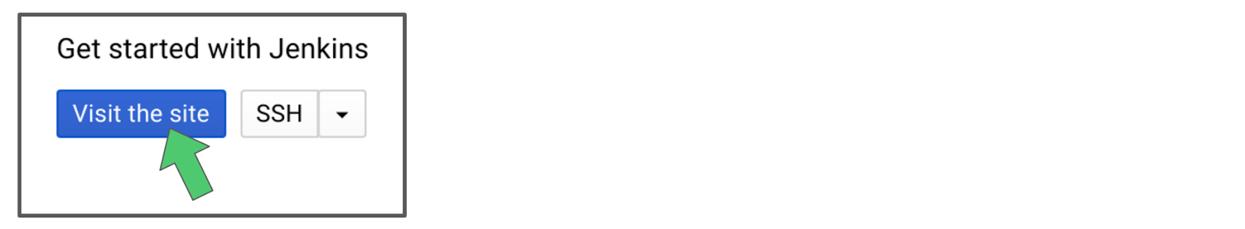

Login with the Username and Password.



## ****Step 4: Explore the application****

In the Jenkins interface, in the menu on the left, select **[Manage Jenkins]**

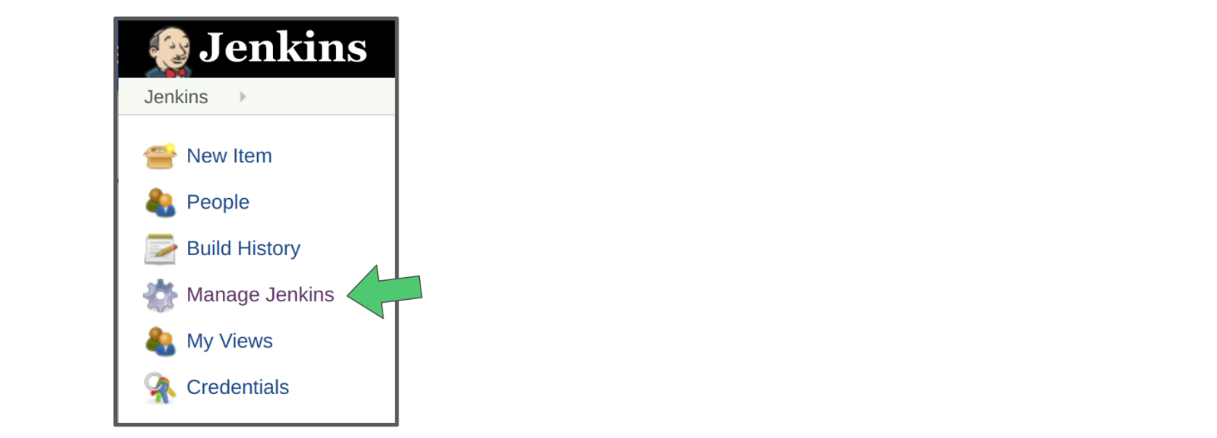

And look at all of the actions available. You are now prepared to manage Jenkins. The purpose of this lab is GCP infrastructure, not Jenkins management, so viewing that this menu was available was the purpose of this step.

Result:

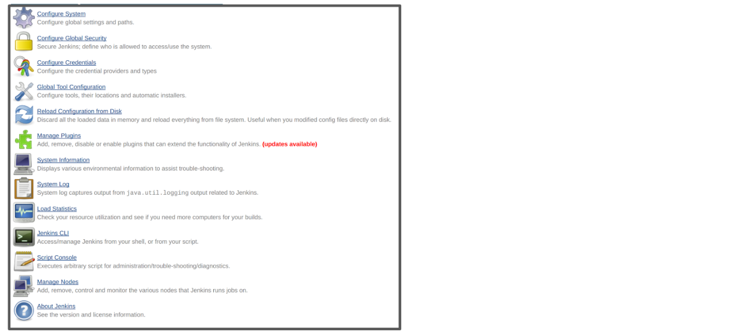

Leave the browser window open to the Jenkins service. You will use it in the next steps.

Now you have seen that the software is installed and working properly. In the next section you will open an SSH terminal session to the VM where the service is hosted, and verify that you have administrative control over the service.

# Administer the service

## ****Step 1: View the Deployment****

Return to the Console.

If you have navigated away from the Jenkins deployment in GCP, you can return by locating it in Deployment Manager.

Console: **Products and Services > Deployment Manager**

Click on the **[jenkins]** deployment.

## ****Step 2: SSH to the Virtual Machine****

Connect to the Jenkins server using the SSH button.

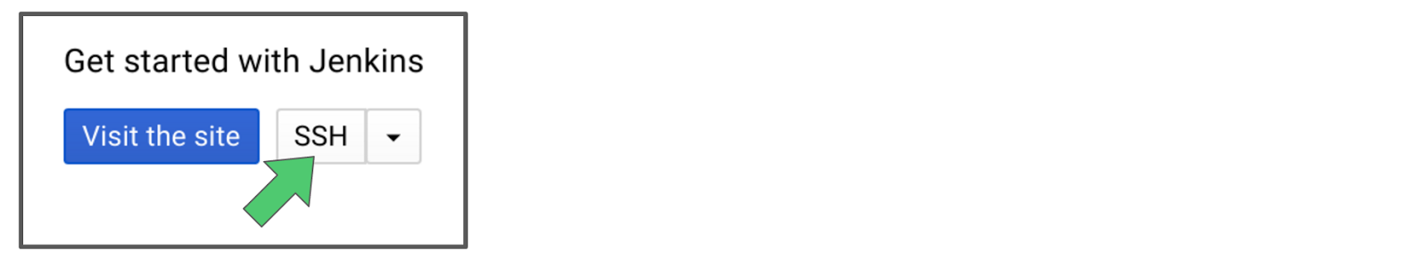

Result:

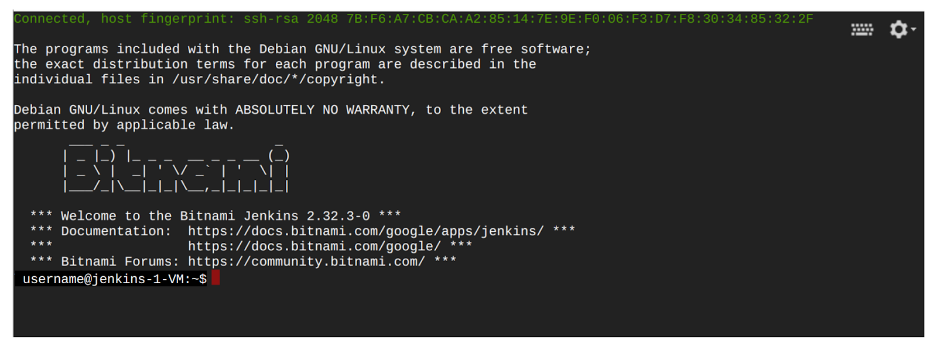

The Console interface is performing several tasks for you transparently. One example is that It has transferred keys to the virtual machine that is hosting the Jenkins software so that you can connect securely to the machine using SSH.

## ****Step 3: Administratively shut down the services****

Enter the following command to shut down all the running services.

 Copy Code Block

sudo /opt/bitnami/ctlscript.sh stop

Result:

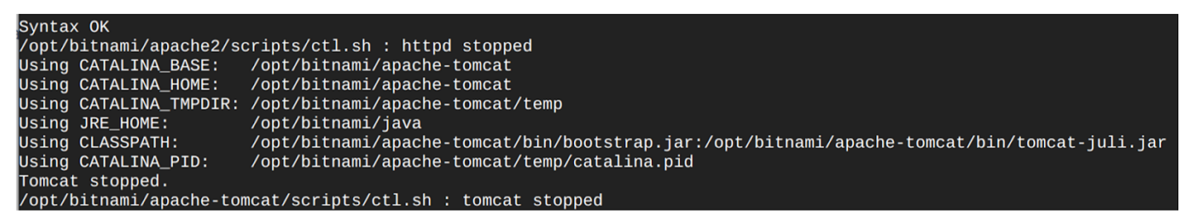

Refresh the browser window to the Jenkins UI. It should produce an error message indicating that the connection was refused.

## ****Step 4: Administratively restart the services****

Enter the following command to restart the services.

 Copy Code Block

sudo /opt/bitnami/ctlscript.sh restart

Result:

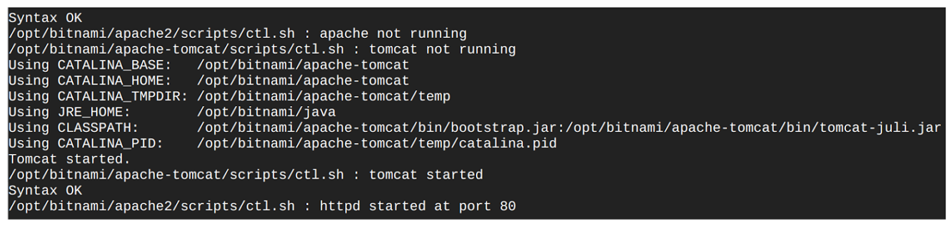

Return to the browser window for the Jenkins UI and refresh it. You may have to do it a couple of times before the service is reachable. Wait until the browser refreshes and shows that Jenkins is operational once more.

Type **exit** to close the SSH terminal session.

# Review

In a few minutes you were able to launch a complete Continuous Integration solution. You demonstrated that you had user access through the Jenkins UI. And you demonstrated that you had administrative control over Jenkins by SSH'ing to the VM where the service is hosted and by stopping and then restarting the services.

|  |
| --- |
| **Levels:**[**introductory**](https://googlecloud.qwiklabs.com/tags/introductory/level)  **Lab Description:**In this lab you will use Cloud Launcher to examine some of the powerful infrastructure features available in GCP. Many of the services that are used automatically in this lab will be explored in detail later in the class.  **Lab Creator:** Enis Konuk  **Date Created:** April 10, 2017 19:11 |